20k-0244

20k-1045

20k-1061

20k-1703

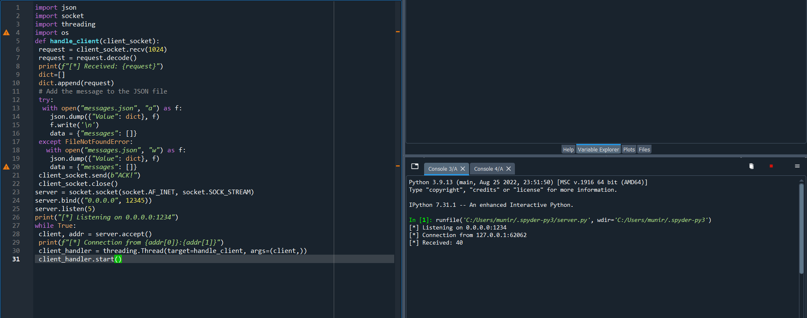

import json

import socket

import threading

import os

def handle_client(client_socket):

request = client_socket.recv(1024)

request = request.decode()

print(f"[*] Received: {request}")

dict=[]

dict.append(request)

# Add the message to the JSON file

try:

with open("messages.json", "a") as f:

json.dump({"Value": dict}, f)

f.write('\n')

data = {"messages": []}

except FileNotFoundError:

with open("messages.json", "w") as f:

json.dump({"Value": dict}, f)

data = {"messages": []}

client_socket.send(b"ACK!")

client_socket.close()

server = socket.socket(socket.AF_INET, socket.SOCK_STREAM)

server.bind(("0.0.0.0", 12345))

server.listen(5)

print("[*] Listening on 0.0.0.0:1234")

while True:

client, addr = server.accept()

print(f"[*] Connection from {addr[0]}:{addr[1]}")

client_handler = threading.Thread(target=handle_client, args=(client,))

client_handler.start()

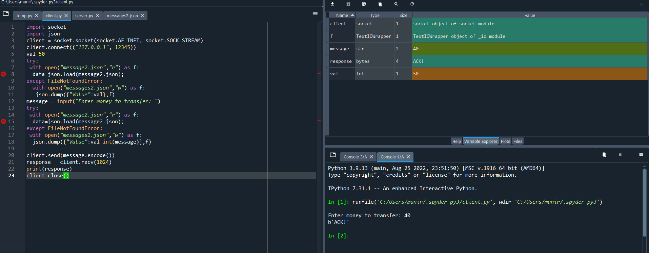

import socket

import json

client = socket.socket(socket.AF_INET, socket.SOCK_STREAM)

client.connect(("127.0.0.1", 12345))

val=50

try:

with open("message2.json","r") as f:

data=json.load(message2.json);

except FileNotFoundError:

with open("messages2.json","w") as f:

json.dump({"Value":val},f)

message = input("Enter money to transfer: ")

try:

with open("message2.json","r") as f:

data=json.load(message2.json);

except FileNotFoundError:

with open("messages2.json","w") as f:

json.dump({"Value":val-int(message)},f)

client.send(message.encode())

response = client.recv(1024)

print(response)

client.close()

